AIM:
To determine the Impact toughness (strain energy) through Izod test and Charpy test
THEORY:
In a impact test a specially prepared notched specimen is fractured by a single blow from a heavy hammer and energy required being a measure of resistance to impact. Impact load is produced by a swinging of an impact weight W (hammer) from a height h. Release of the weight from the height h swings the weight through the arc of a circle, which strikes the specimen to fracture at the notch (fig..
Kinetic energy of the hammer at the time of impact is mv² /2, which is equal to the relative potential energy of the hammer before its release. (mgh),where m is the mass of the hammer and 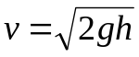 is its tangential velocity at impact, g is gravitational acceleration (9.806 m/s²) and h is the height through which hammer falls. Impact velocity will be 5.126 m/s or slightly less.
Here it is interesting to note that height through which hammer drops determines the velocity and height and mass of a hammer combined determine the energy. Energy used can be measured from the scale given. The difference between potential energies is the fracture energy. In test machine this value indicated by the pointer on the scale. If the scale is calibrated in energy units, marks on the scale should be drawn keeping in view angle of fall () and angle of rise (. Height h1 and h2 equals,
With the increase or decrease in values, gap between marks on scale showing energy also increase or decrease. This can be seen from the attached scale with any impact machine.
Energy used in fracturing the specimen can be obtained approximately as Wh1Wh2
This energy value called impact toughness or impact value, which will be measured, per unit area at the notch.
Izod introduced Izod test in 1903. Test is as per the IS: 1598
Charpy introduced Charpy test in 1909. Test is as per the IS: 1499.

a. Izod test
Specimen and equipment
1. Impact testing machine.(fig.3)
2. Specimen and v notch is shown in the fig.4. Size of the specimen is 10mm X 10mm X 75mm
Mounting of the specimen:
Specimen is clamped to act as vertical cantilever with the notch on tension side. Direction of blow of hammer is shown in fig. (). Direction of blow is shown in fig
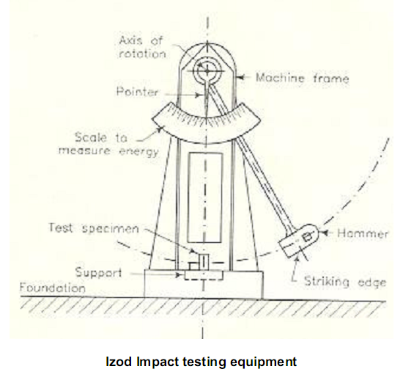
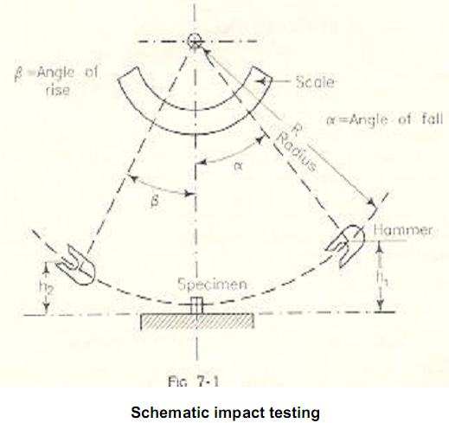
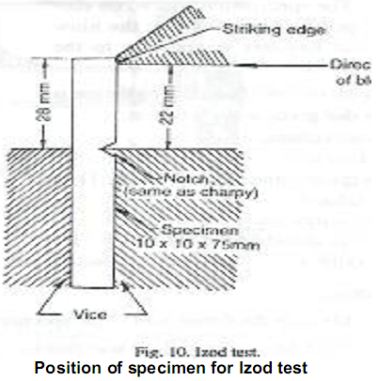
PROCEDURE:
1. Measure the dimensions of a specimen. Also, measure the dimensions of the notch.
2. Raise the hammer and note down initial reading from the dial, which will be energy to be used to fracture the specimen.
3. Place the specimen for test and see that it is placed center with respect to hammer. Check the position of notch.
4. Release the hammer and note the final reading. Difference between the initial and final reading will give the actual energy required to fracture the Specimen.
5. Repeat the test for specimens of other materials.
6. Compute the energy of rupture of each specimen.
OBSERVATION:
Initial and final reading of the dial.
Result Strain energy of given specimen is

b. Charpy test
Specimen and equipment:
1. Impact testing machine. (Fig.6)
2. U notch is cut across the middle of one face as shown in (fig.5).
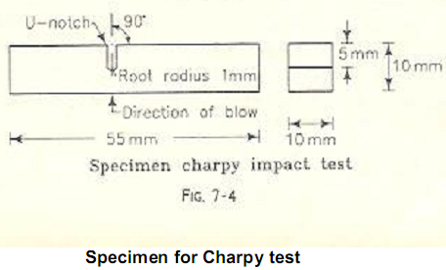
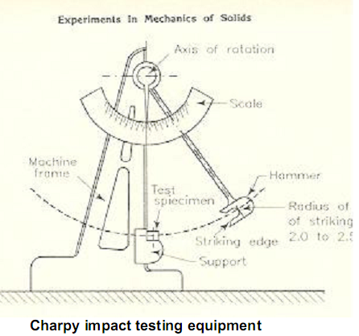
Mounting of specimen
Specimen is tested as a beam supported at each end (fig.7). Hammer is allowed to hit then specimen at the opposite face behind the notch.
Figure.7
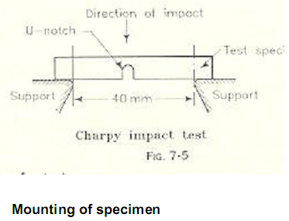
Procedure
1. Measure the dimensions of a specimen. Also, measure the dimensions of The notch.
2. Raise the hammer and note down initial reading from the dial, which will be energy to be used to fracture the specimen.
3. Place the specimen for test and see that it is placed center with respect to hammer. Check the position of notch.
4. Release the hammer and note the final reading. Difference between the initial and final reading will give the actual energy required to fracture the Specimen.
5. Repeat the test for specimens of other materials.
6. Compute the energy of rupture of each specimen.
OBSERVATION:
Initial and final reading of the dial.
Result Strain energy of given specimen is
PART – 2
ANIMATION STEPS
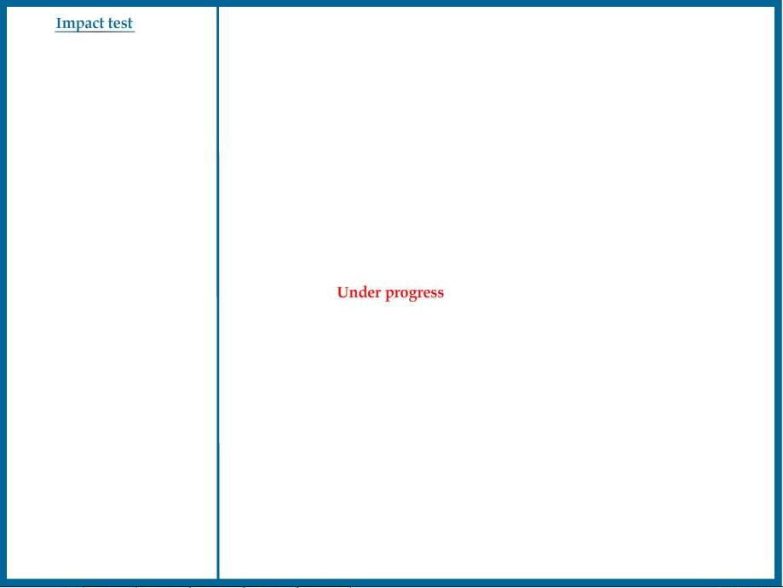

PART – 3
VIRTUAL LAB FRAME

